**Homeostasis**

1. What is homeostasis? _________________________________________________________________________________

_____________________________________________________________________

1. Homeostasis exists to keep what four aspects of our bodies in balance?
2. ____________________________
3. ____________________________
4. ____________________________
5. ____________________________
6. Water level control:
7. Gas level control:
8. How does the body remove excess carbon dioxide from the body? _________________________________________________________________________________
9. Body temperature control:
10. What is the approximate normal core temperature for the body?

_________________________________________________________________________________

1. Explain what happens to our bodies if we get too hot?

Sweating:__________________________________________________________________________________________________________________________________________

Vasodilation:__________________________________________________________________________________________________________________________________________

1. What will the body do if it gets too cold?

Piloerection:__________________________________________________________________________________________________________________________________________

Vasoconstriction:__________________________________________________________________________________________________________________________________________

1

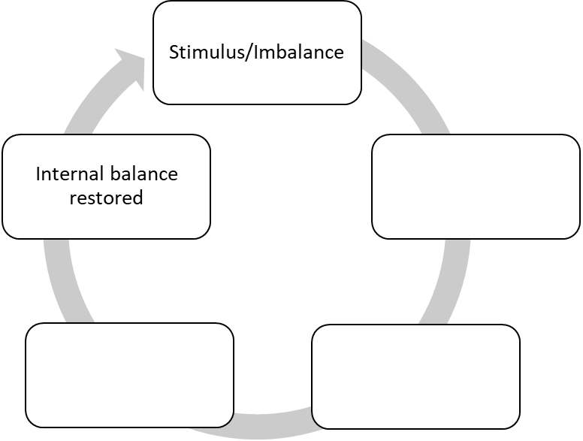

5

4

3

2

**Label the blank boxes with the three missing components of the feedback loop;**

Receptor (sensor) Control Center Effector

**Using the diagram above, place the correct number of the order the event occurs next to the description;**

____ Response of the effectors feeds back to influence the initial stimulus

____ Stimulus produces change in the variable causing an imbalance in homeostasis

____ Information is processed by the receptor and sent to the control center

____ Change is detected by receptor

____ Information from the receptor has been processed and instructions on what action is needed is sent to effector